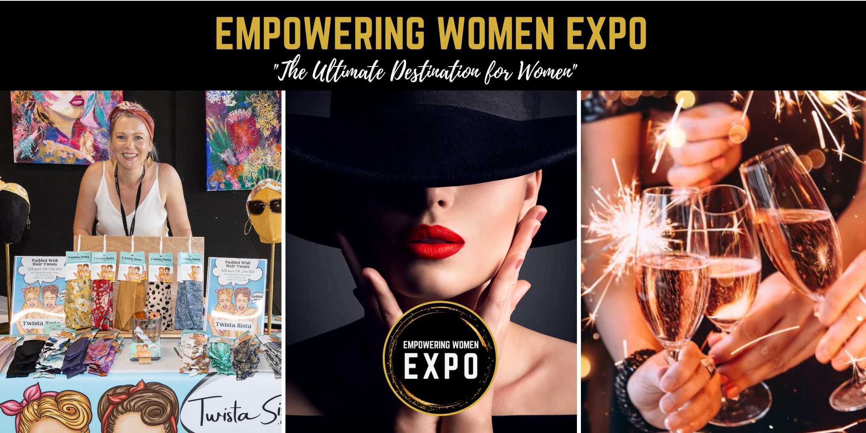

**Exhibitor Info Kit 2024**

Friday 8th November, 3pm to 8pm

Venue 114, Lake Kawana

**Empowering Women EXPO**

**The Sunshine Coast’s Most Anticipated Event for Women**

Congratulations!

It is with great pleasure that we extend this invitation to the 16th Annual **Empowering Women EXPO** (formerly Women’s Lifestyle Expo), proudly hosted by Fabe Keily and team from the Empowering Women Network.

Mark your calendars, and don't miss out on this one-of-a-kind event! The ICONIC Empowering Women EXPO is the ultimate destination for women looking for inspiration, empowerment, and a great time.

On Friday 8th November, Venue 114 at Lake Kawana will be transformed into a haven for women aged 18 yrs to 55+ yrs.  From 3pm to 8pm, visitors will have the opportunity to browse, shop, sip, socialise and experience everything from fashion & beauty to health & fitness, Artisan goods, Christmas gift ideas, food & beverage taste testings, business & career opportunities and much more, all under one roof!

Throughout the afternoon & evening, empowering speakers will share their knowledge and offer demonstrations in the areas of health, wealth, finance, fitness, beauty, personal development and more.

With 50+ pop-up shops and exhibits, the Empowering Women EXPO is the perfect place for local businesses to showcase their brand, tell their story and sell their products to a HIGHLY targeted audience of women 18yrs to 55+ yrs.  We can't wait to see you there!

This document contains useful details to ensure the success of your exhibit and ultimately the event. For more information

Please contact:

Fabe Keily | [fabe@fabekeily.com](mailto:fabe@fabekeily.com)

Office Mob 0411 108 309

**Overview of the Event:**

**Date:** Friday 8th November, 2024

**Location:** Venue 114, Lake Kawana

**Demographic:** Women 18yrs to 55+ yrs

**Attendees:** 1,000 + Expected Visitors

**Exhibits:** 50+ Pop-Up Shops & Exhibits

**Highlights:** Fashion Parades, Speakers, Demonstrations

**Target Market:**

The Empowering Women EXPO is an event for women of all ages which gives local businesses the opportunity to showcase their products and services to a HIGHLY targeted audience of women 18yr to 55yrs + all in one place. Based on the success of the past 15 years, we have a large database of past attendees who love the event and are keen to attend in 2024.

Through the use of extensive social media marketing, **the Empowering Women EXPO is marketed collaboratively by all of our Exhibitors and Market Stall Holders** resulting in over 1,000 women attending the event from across the Sunshine Coast and beyond. This truly is a unique event aimed at bringing women together to connect, collaborate and celebrate.

**Why Exhibit?**

We are passionate about helping local businesses to connect with their target audience, generate more leads and make more sales.

Do you need more customers?

Do you need to be more visible?

Do you need more referral partners?

Do you need to make more sales?

Do you want to showcase new products and services?

* **Connect with over 1,000 highly engaged women who are keen to grow in the areas of health, finance, fitness, fashion and much more!**
* Generate high-quality leads and make valuable connections with other industry professionals.
* **Build brand awareness and increase your visibility in the marketplace**
* Showcase your products and services in a dynamic, engaging setting that is sure to make a lasting impression on attendees.

**Extra Inclusions:**

It’s not just about the day as we want to ensure your business is at the forefront of people’s minds. See extra inclusions for ALL Exhibitors Below

* Table & Chair/s
* Booth Backing Boards for 2m and 3m Exhibits
* Online Marketing
* Flyers & Posters
* Online Ticketing
* Food & Drink Sales
* Direct Email Campaigns
* Professional Fashion Parades
* Free Social Media Posts - 4 months
* Free Website Listing – 4 months

**Sponsorship Opportunities:**

Each year we have a limited number of sponsorship opportunities for businesses who are wanting to SUPERSIZE their brand awareness and exposure at the EXPO. See [www.fabekeily.com/expo](http://www.fabekeily.com/expo) for details.

